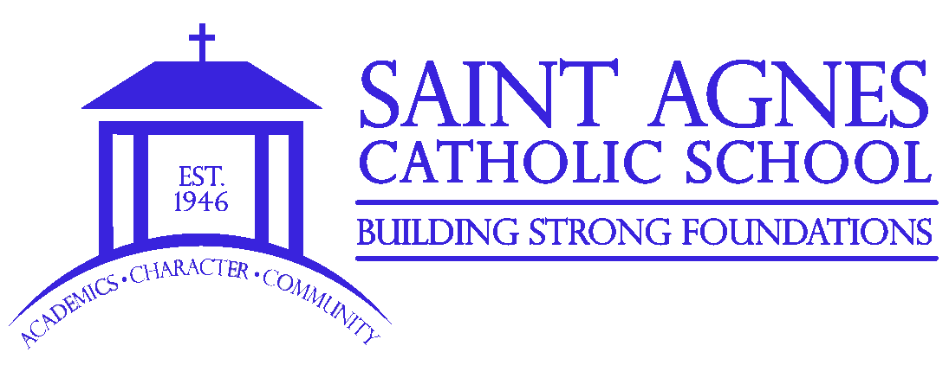
PARENT QUICK GUIDE FOR COVID-19
- Send results of negative test to school nurse for clearance
- Attend School

- Isolate for 10 days
- Student may return to school after 10 days when they are fever free for 24 hours without medication
Option 1:
Provide proof of up-to-date vaccination to school nurse and return to school
Option 2:
Complete a 5-day quarantine and return to school on day 6
Stay Home
Option 1:
- Obtain a provider-attended PCR test
- Send negative results to the school nurse for clearance
NO
YES
Has your child received laboratory report of positive results, or been diagnosed by a healthcare provider as having COVID-19?
NO
YES
Option 2:
- Seek support from a healthcare provider
- Receive clearance from a healthcare provider to return
YES
Stay out of school until symptoms subside for at least 48 hours
Attend School

NO
Do they have symptoms that could be contagious?
NO
YES
Your child has been identified as a “Close Contact” by St. Agnes School or a health department. Do they also have symptoms?
Updated January 2022
Does your child have symptoms that could be a sign of COVID-19?

